Parents Grand Parents Gr Grand Parents * Gr Gr Grand Parents * Gr Gr Gr Grand Parents
This rabbit's call name:  _______________________________  Registered Name__________________  ________________________________  Registered #_____________________  Breed __Rex____________________  Variety______________ Sex_________  Color____________________________  Markings________________________  ________________________________  Birthdate___March 2, 2013______  Tattoo___________________________  Breed: Rex  Varieties in Litter:  castor, broken castor, broken black  # in Litter: 8  Bred by: Abra Karhan  Desert Sage Rabbitry  PO Box 336  Saint Stephens, WY 82524  307-709-7212  desertsagerabbitry@hotmail.com | Sire's bloodline  Sire: WW Buzzn the Stars  Ear # WW46 GC #  Reg # L0637K Wt: 8.04  Variety: broken black  very speckly  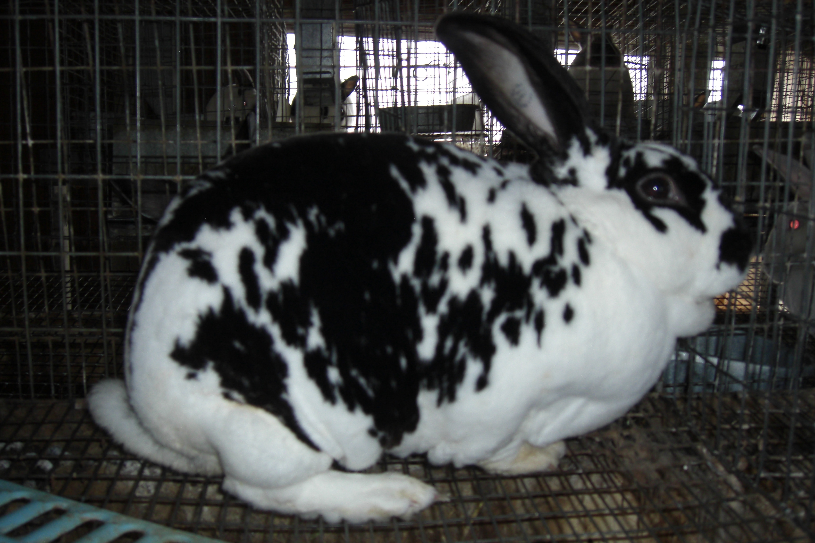 | G Sire: WW Buzz  Ear # WW22 GC  Reg # Wt 8.07  Variety: blue | GG Sire: WW Tom  Ear # WW020 GC # 4 legs  Reg # Wt 8.07  Variety: Black Otter | Ear # PR83R Wt. 8.08  Reg # GC# 1 leg  Variety: blue | 1.
 |  |  |  |  | 2.
 |  |  |  | Ear # 82HTR Wt. 8.03  Reg # GC#  Variety: black otter | 3. HT's 27HTR castor 8.7
 |  |  |  |  | 4. HT's 51HTR black otter 8.3
 |  | G Sire: WW Buzz  Ear # WW22 GC  Reg # Wt 8.07  Variety: blue | GG Dam: WW Rosie  Ear # WW018 GC # 3 legs  Reg # Wt 8.07  Variety: 8.07 | Ear # PR83R Wt. 8.08  Reg # GC# 1 leg  Variety: blue | 5.
 |  |  |  |  | 6.
 |  |  |  | Ear # 82HTR Wt. 8.03  Reg # GC#  Variety: black otter | 7. HT's 27HTR castor 8.7
 |  |  |  |  | 8. HT's 51HTR black otter 8.3
 |  | G Dam: Star  Ear # S1 GC #  Reg # Wt 9.02  Variety: red eyed white | GG Sire: Broken Arrows 30  Ear # 30BAR GC #  Reg # Wt 9.0  Variety: white  BOV & BOS @HTRC 2007  BOB @ LC7 2008 | Ear # BAR5 Wt. 9.05  Reg # GC# 3 legs  Variety: white | 9.
 |  |  |  |  | 10. Ear# Wt. Var
 |  |  |  | Ear # EP59 Wt. 8.15  Reg # L821E GC# Y2259  Variety: white 3 legs | 11 Ear# Wt. Var
 |  |  |  |  | 12. Ear# Wt. Var
 |  |  | GG Dam: Beauty T2  Ear # T2 GC #  Reg # Wt 10.0  Variety: white | Ear # PS605 Wt. 9.04  Reg # GC#  Variety: white | 13. Ear# Wt. Var
 |  |  |  |  | 14 Ear# Wt. Var
 |  |  |  | Ear # BR7 Wt. 10  Reg # GC# BOB @ LCF 2006  Variety: broken black | 15. Ear# Wt. Var
 |  |  |  |  | 16. Ear# Wt. Var
 | Dam's bloodline ~~~~~~~~~~~~~~~~~~ Dam: Desert Sage 3DS  Ear # 3DS GC #  Reg # L638K Wt 8.04  Variety: broken castor  blanket pattern  3rd of 6 @PPRB 2012  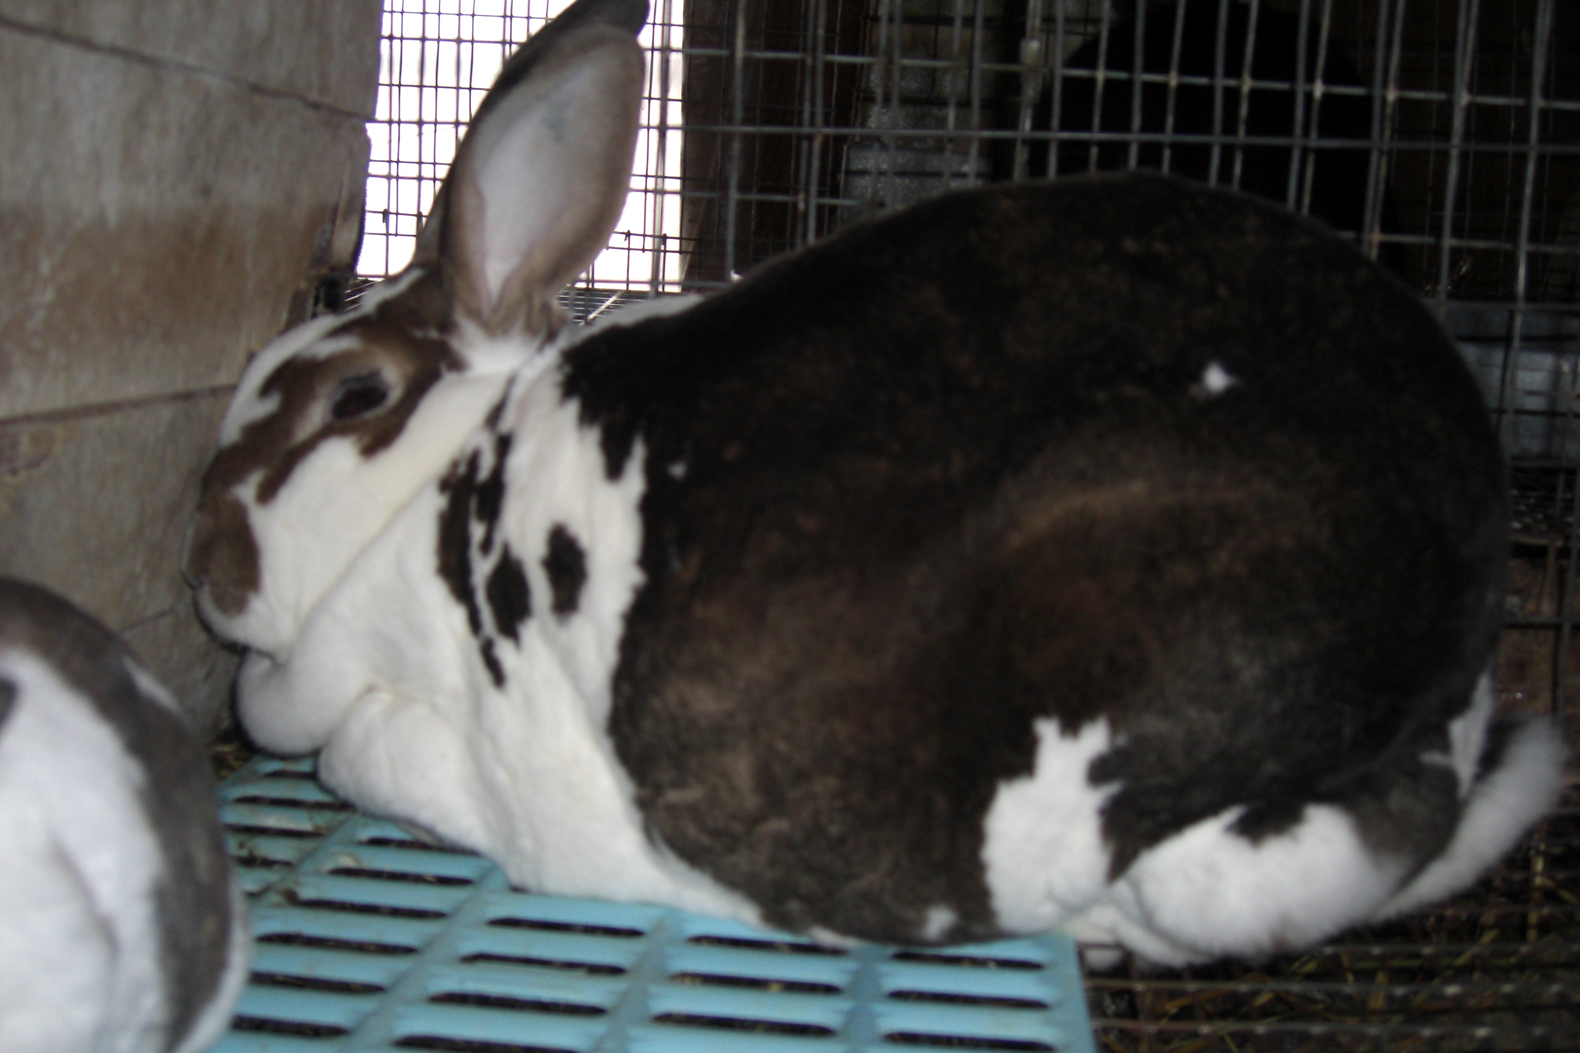 | ~~~~~~~~~~~~~~~~~~~~~~~~~~~~~~~  G Sire: Willow's Tiny  Ear # 9W151 GC #  Reg # Wt 9.0  Variety: broken black blanket | ~~~~~~~~~~~~~~~~~~~~~~~~~~~~~~~  GG Sire: Kristen's 3MZKH  Ear # 3MZKH GC # 6 legs  Reg # Wt. 8.11  Variety: broken black  2 BOB; 2 BOV; 1BOSV; 1 BOS | Ear # LXZ120 Wt. 9.08  Reg # Y880B GC# Z2617  Variety: white | 17. Szychulda's LU Wt. 9.0 Var: white
 |  |  |  |  | 18. Szychulda's Blitz Wt. 9.05 Var: white
 |  |  |  | Ear # 94KH Wt. 9.0  Reg # GC#  Variety: broken black | 19. Ear# KHER Wt. 10.0 Var: black otter
 |  |  |  |  | 20. Ear# 25KH Wt. 9.05 Var: broken black 8 legs
 |  |  | GG Dam: Willows 7W34  Ear # 7W34 GC # 3 legs  Reg # Wt 8.02  Variety: broken black  2BOB; 1 BOV | Ear # 6JC9 Wt. 8.15  Reg # 2 BIS; 1 BOSV GC# 3 legs  Variety: black otter | 21. # E860 Wt. 8.08 black otter 6 legs Reg# Z00866Y
 |  |  |  |  | 22. Ear# W512 Wt. 8.04 black otter 1 leg
 |  |  |  | Ear # C110 Wt. 9.02  Reg # GC#  Variety: broken black | 23. Ear# W481 Wt. 8.04 broken black 22 legs
 |  |  |  |  | 24. Ear# DS557 Wt. 8.00 black 4 legs
 |  | G Dam: DHRR Maybee  Ear # MBE GC #  Reg # Wt 8.0  Variety: broken castor | GG Sire:  Ear # PTR GC #  Reg # Wt 8.0  Variety: broken castor | Ear # PTH Wt. 8.0  Reg # GC#  Variety: broken castor | 25. Ear# Wt. Var
 |  |  |  |  | 26. Ear# Wt. Var
 |  |  |  | Ear # PST Wt. 9.0  Reg # GC#  Variety: broken castor | 27. Ear# Wt. Var
 |  |  |  |  | 28. Ear# Wt. Var
 |  |  | GG Dam:  Ear # MBD GC #  Reg # Wt 9.0  Variety: castor | Ear# KSD Wt. 9.0  Reg #  Variety: red | 29. Ear# Wt. Var
 |  |  |  |  | 30. Ear# Wt. Var
 |  |  |  | Ear # MBP Wt. 9.0  Reg # GC#  Variety: castor | 31. Ear# Wt. Var

Grand champion has a show record is registered registered with a show record S - sire D - dam
* this generation is not required for registration purposes

* *Gr Gr Gr Gr Grandparents *Gr Gr Gr Gr Gr Gr Grandparents
1. | Ear wt. var. | S Var. D Var.
1. | Ear wt. var. | S Var. D Var.
2. | Ear wt. var. | S Var. D Var.
2. | Ear wt. var. | S Var. D Var.
3. | PR42R black otter 8.8 BOV Rex Nationals 4-05 | S Var. D Var.
3. | ME502 castor 8.4 BIS WHRC Yth Show 5-05 | S Var. D Var.
4. | PR42R black otter 8.8 BOV Rex Nationals 4-05 | S Var. D Var.
4. | HT155 broken black 8.0 | S Var. D Var.
5. | Ear wt. var. | S Var. D Var.
5. | Ear wt. var. | S Var. D Var.
6. | Ear wt. var. | S Var. D Var.
6. | Ear wt. var. | S Var. D Var.
7. | PR42R black otter 8.8 BOV Rex Nationals 4-05 | S Var. D Var.
7. | ME502 castor 8.4 BIS WHRC Yth Show 5-05 | S Var. D Var.
8. | PR42R black otter 8.8 BOV Rex Nationals 4-05 | S Var. D Var.
8. | HT155 broken black 8.0 | S Var. D Var.
9. | Ear wt. var. | S Var. D Var.
9. | Ear wt. var. | S Var. D Var.
10. | Ear wt. var. | S Var. D Var.
10. | Ear wt. var. | S Var. D Var.
11. | Ear wt. var. | S Var. D Var.
11. | Ear wt. var. | S Var. D Var.
12. | Ear wt. var. | S Var. D Var.
12. | Ear wt. var. | S Var. D Var.
13. | Ear wt. var. | S Var. D Var.
13. | Ear wt. var. | S Var. D Var.
14. | Ear wt. var. | S Var. D Var.
14. | Ear wt. var. | S Var. D Var.
15. | Ear wt. var. | S Var. D Var.
15. | Ear wt. var. | S Var. D Var.
16. | Ear wt. var. | S Var. D Var.
16. | Ear wt. var. | S Var. D Var.
~~~~~~~~~~~~~~~~~~~~~~~~~~~~~~~~~~~~~~~~~~~~~~~~~~~~~~~~~~~~~~~~~~~~~~~~~~~~~~~~~~~~~~~~~~~~~~~~~~~~~~~~~~~~~~~~~~~~~~~~~
17. | Ear wt. var. | S Var. D Var.
17. | Ear wt. var. | S Var. D Var.
18. | Ear wt. var. | S Var. D Var.
18. | Ear wt. var. | S Var. D Var.
19. | Ear wt. var. | S Var. D Var.
19. | Ear wt. var. | S Var. D Var.
20. | Ear wt. var. | S Var. D Var.
20. | Ear wt. var. | S Var. D Var.
21. | Ear wt. var. | S Var. D Var.
21. | Ear wt. var. | S Var. D Var.
22. | Ear wt. var. | S Var. D Var.
22. | Ear wt. var. | S Var. D Var.
23. | Ear wt. var. | S Var. D Var.
23. | Ear wt. var. | S Var. D Var.
24. | Ear wt. var. | S Var. D Var.
24. | Ear wt. var. | S Var. D Var.
25. | Ear wt. var. | S Var. D Var.
25. | Ear wt. var. | S Var. D Var.
26. | Ear wt. var. | S Var. D Var.
26. | Ear wt. var. | S Var. D Var.
27. | Ear wt. var. | S Var. D Var.
27. | Ear wt. var. | S Var. D Var.
28. | Ear wt. var. | S Var. D Var.
28. | Ear wt. var. | S Var. D Var.
29. | Ear wt. var. | S Var. D Var.
29. | Ear wt. var. | S Var. D Var.
30. | Ear wt. var. | S Var. D Var.
30. | Ear wt. var. | S Var. D Var.
31. | Ear wt. var. | S Var. D Var.
31. | Ear wt. var. | S Var. D Var.
32. | Ear wt. var. | S Var. D Var.
32. | Ear wt. var. | S Var. D Var.

