Puppies flying home on the airlines are fed a mix of Iams Large Breed Puppy and
Purina One Large Breed Puppy because they are in a number of department and grocery stores so I don't have to ship food a week ahead of the puppy. If you can only find one of these foods locally it is ok. Since your pup is used to both it won't be a sudden diet change.
If you can not find either of these foods locally I can ship a little ahead of your puppy so you can use it to switch him over to his new diet. Or if I can find "your" food locally I can switch his diet before he flies. Please note I may ask for funds to buy the food or cover shipping expenses.

Iams 2 ½ * Purina One 2 *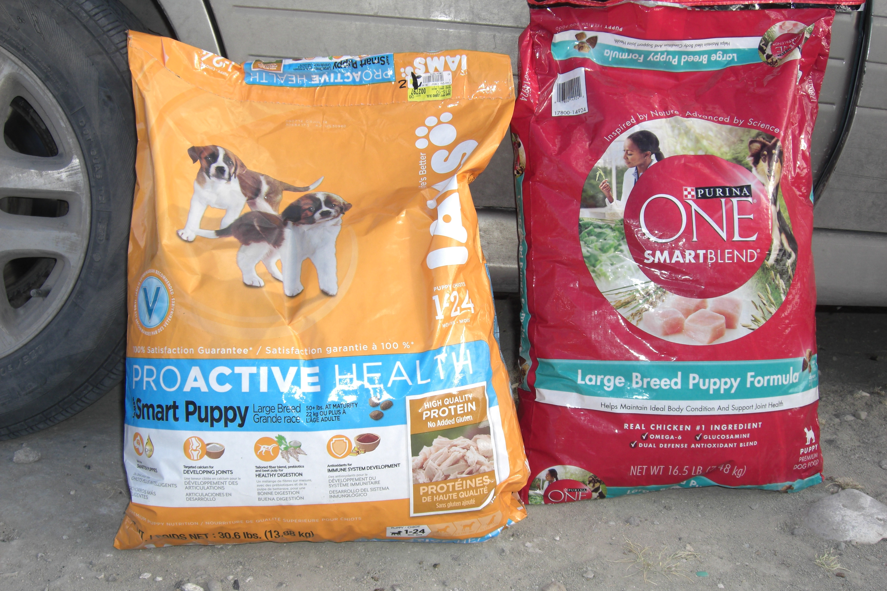

You should find a plastic bag with these mixed foods taped to the top of your puppy's airline crate if the airline personel did not feed it all to the puppy.

Feel free to visit The Dog Food Advisor.com to learn more about these foods so you can plan your growing puppy's diet.

